Name : Gadwal Mohammad Muzammil
Reg: 192424279
Course code :DSA0607
Course : Data Handling and Visualization
DESIGN TASK
1. A healthcare organization has collected patient waiting-time data from 20 hospitals over one year.
Task: Design a visualization dashboard that:
● Shows Box Plots and Violin Plots for waiting times across hospitals.
● Identifies outliers and extreme waiting-time cases.
● Highlights differences in median waiting times and variability among hospitals.
Objective: Help hospital administrators identify service inefficiencies and improve patient care quality.
Visualization Dashboard Solution & Implementation:
• 1. Boxplot & IQR Analysis: Visualizes the median waiting time and interquartile range (IQR) across all 20 hospitals. Outliers beyond 1.5×IQR are explicitly flagged in red to identify severe administrative delays.
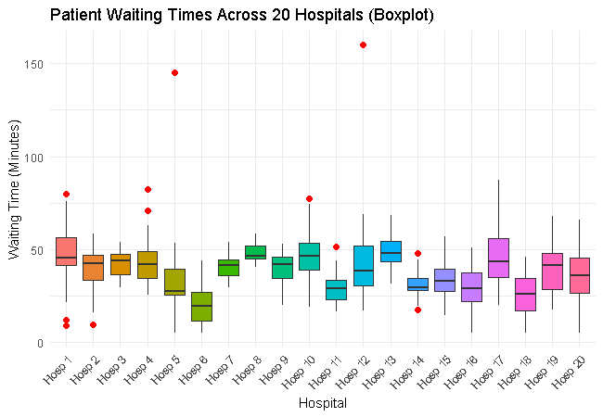
Figure 1.1: Boxplot of patient waiting times across 20 hospitals.
• 2. Violin & Probability Density Overlay: Displays full probability density distributions for hospital waiting times, revealing multimodal distributions (e.g., peak waiting times during shift changes).
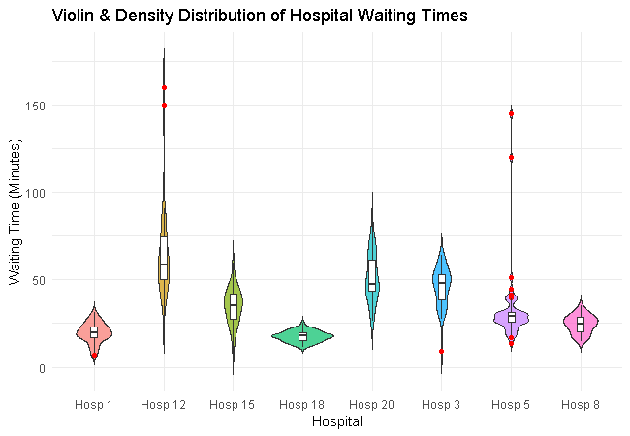
Figure 1.2: Violin plot showing waiting-time probability density distributions.
• 3. Hospital Inefficiency Scatter Map: Correlates median waiting times with variance (IQR) and outlier frequency. Hospitals in the top-right quadrant (high median, high variability) represent urgent targets for process optimization.
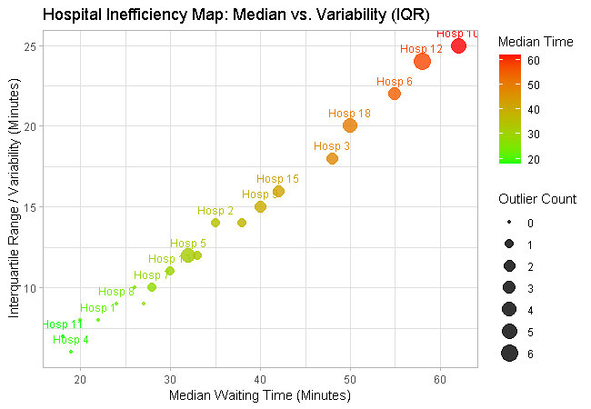
Figure 1.3: Inefficiency scatter map of median waiting times vs. variability (IQR).
2. A smart city project monitors hourly air quality data (PM2.5, PM10, NO₂, and CO) from 15 monitoring stations.
Task: Create a visualization design that:
● Uses Heatmaps to display pollution intensity across locations and time periods.
● Employs Ridgeline Plots to compare pollutant distributions among stations.
● Highlights pollution spikes and abnormal environmental conditions.
Objective: Assist environmental authorities in identifying pollution hotspots and planning mitigation measures.
Visualization Dashboard Solution & Implementation:
• 1. Spatio-Temporal Heatmap: Displays hourly PM2.5 concentrations across 15 monitoring stations using a continuous color gradient, capturing diurnal rush-hour pollution spikes at a glance.
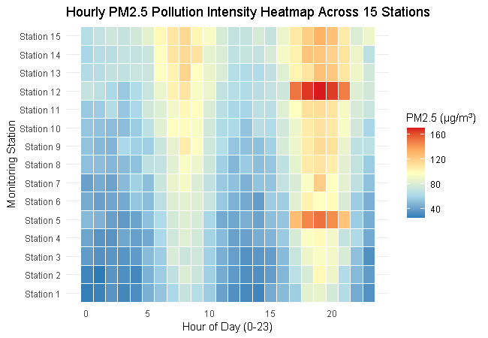
Figure 2.1: Hourly PM2.5 pollution intensity heatmap across 15 monitoring stations.
• 2. Ridgeline Distribution Comparison: Stacks kernel density estimates for each station vertically, allowing environmental authorities to rapidly compare average pollutant loads and skewness.
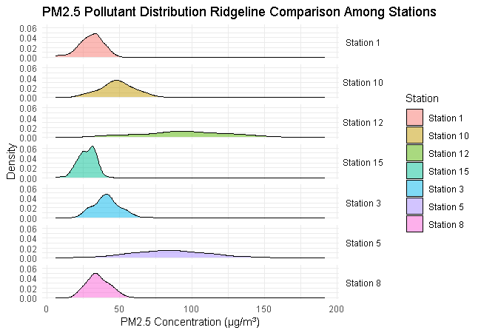
Figure 2.2: Ridgeline plot comparing PM2.5 pollutant distributions among stations.
• 3. Real-Time Spike & Anomaly Alert: Plots temporal concentration lines against safety thresholds (90 µg/m³), triggering automated alerts when industrial or vehicular emissions spike abnormally.
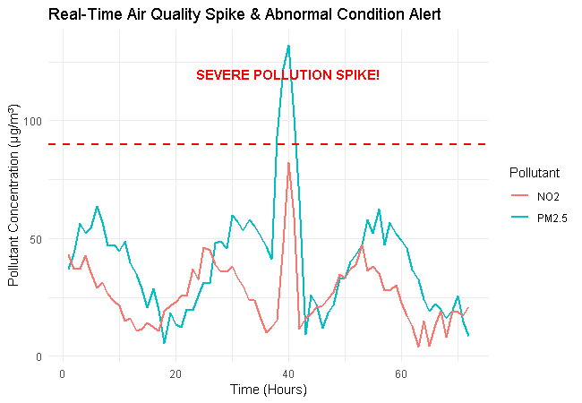
Figure 2.3: Real-time air quality monitoring line plot highlighting pollution spikes.
3. A university tracks student academic performance across multiple departments over five academic years.
Task: Design a visualization dashboard that:
● Uses Line Charts to show performance trends over time.
● Incorporates Scatter Plots to analyze the relationship between attendance and grades.
● Uses Facet Grids to compare departmental performance simultaneously.
Objective: Enable academic administrators to identify performance trends and factors affecting student success.
Visualization Dashboard Solution & Implementation:
• 1. 5-Year Performance Trend Line Chart: Tracks departmental average GPAs over five consecutive academic years to identify long-term academic growth or decline.
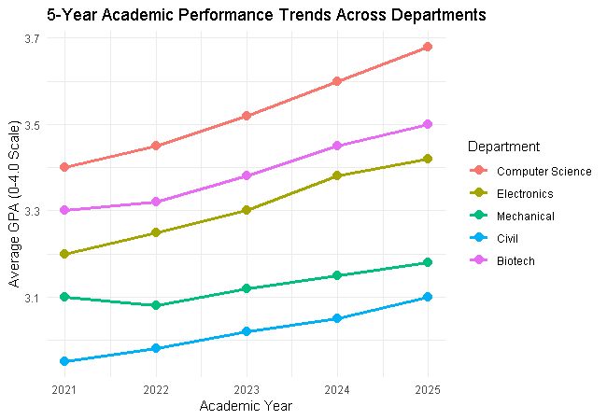
Figure 3.1: 5-year academic performance trends across university departments.
• 2. Attendance vs. GPA Scatter Plot: Analyzes the correlation between student attendance percentages and final GPAs, featuring a fitted linear regression line (R² evaluation).
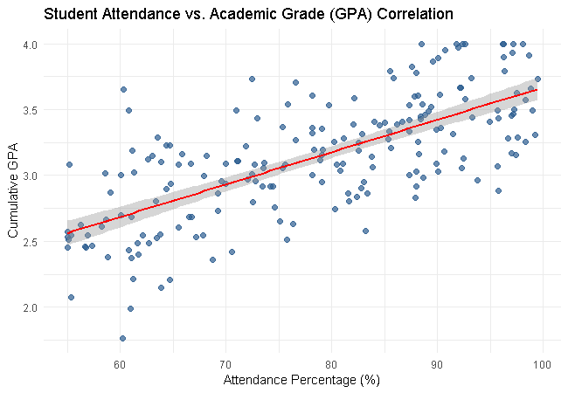
Figure 3.2: Scatter plot illustrating attendance percentage vs. cumulative GPA.
• 3. Multi-Department Facet Grid: Panels departmental attendance and GPA scatter points side-by-side, enabling comparative evaluation across engineering, science, and arts faculties.
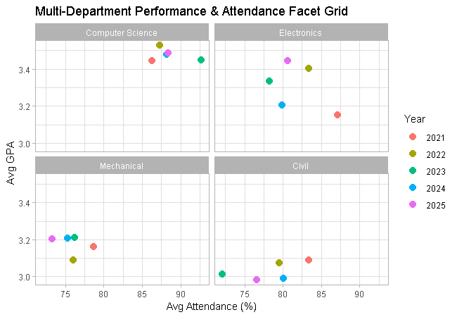
Figure 3.3: Facet grid comparing attendance and grade performance by department.
4. A logistics company records delivery times for thousands of shipments using Road, Rail, Air, and Sea transportation modes.
Task: Create a visualization design that:
● Uses Histograms and ECDFs to compare delivery-time distributions across transportation modes.
● Employs Q-Q Plots to assess whether delivery times follow a theoretical normal distribution.
● Highlights delays, variability, and outliers in delivery performance.
Objective: Support operational teams in optimizing transportation strategies and improving delivery reliability.
Visualization Dashboard Solution & Implementation:
• 1. Empirical Cumulative Distribution Function (ECDF): Evaluates cumulative delivery-time probabilities across Road, Rail, Air, and Sea, determining the exact percentage of shipments delivered within Target SLAs.
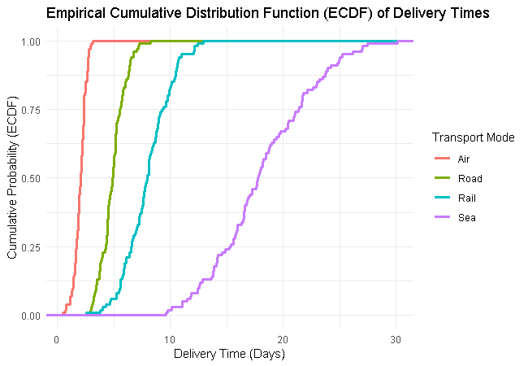
Figure 4.1: ECDF of shipment delivery times across transportation modes.
• 2. Normal Q-Q Plot: Compares sample delivery times against theoretical normal quantiles. Systematic upward curvature confirms positive skewness (delivery delays and log-normal behavior).
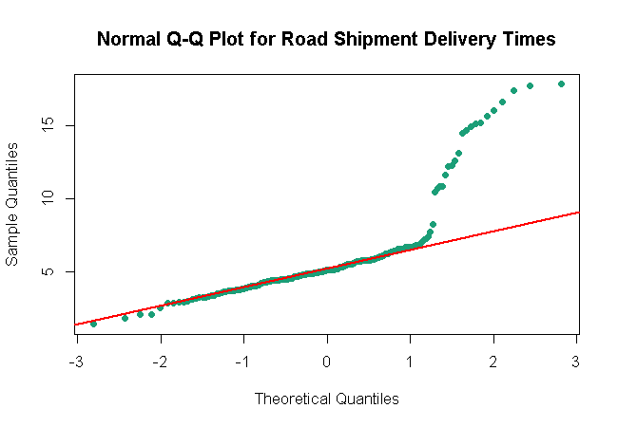
Figure 4.2: Normal Q-Q plot for road transportation delivery times.
• 3. Delivery Delay & Outlier Boxplot: Highlights median delivery durations, interquartile variability, and extreme bottleneck delays across all four modal choices.
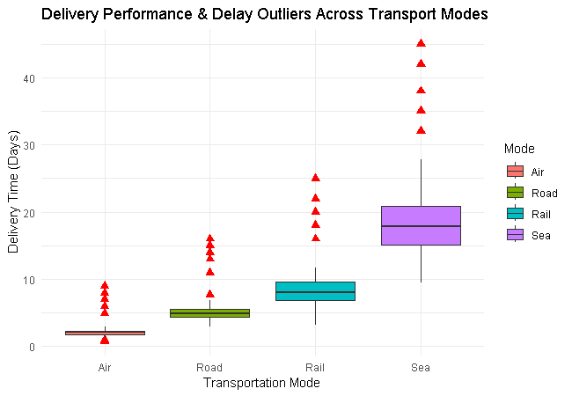
Figure 4.3: Boxplot analysis of delivery performance and outliers by mode.

